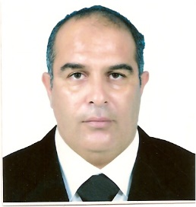
Fathi Elldakli obtained his Bachelors of Science in Petroleum Engineering (1993) from Tripoli University, Libya. He started working for industry as a Production Engineer. After 8 years, Reservoir Engineering recruited him where he worked on various projects. After obtaining good exposure to industrial aspect of Petroleum Engineering, he obtained his Masters of Science in Petroleum Engineering from Heriot-Watt University, UK. In 2008 he offered a position as a dean of Natural Resources College where he taught several Petroleum Engineering courses and supervised student’s projects. In 2012 he enrollment in Master of Science in Petroleum Engineering program at Texas Tech University, US. After finishing the master program he enrolled in the PhD (2014) program in Petroleum Engineering at Texas Tech University, US. Fathi Elldakli has completed various research projects that have had significant impact. He has also been honored with multiple scholarships in recognition of his contributions. His area of expertise is artificial lift development with more emphasis in gas lift system.
Research Interest
I am deeply interested in artificial lift development. I want to focus specifically on the application aspect of the resulting solutions. The major areas of interest are:
- Artificial lift combination to improve well productivity.
- Artificial lift for unconventional reservoir.

