Letter of Confirmation to become Editorial Board Member

Name: Dr. Kaveh Ostad-Ali-Askari

Designation & Affiliation: Assistant Professor, Department of Civil Engineering, Isfahan (Khorasgan) Branch, Islamic Azad University, Isfahan, Iran.

E-mail: Koa.askari@khuisf.ac.ir

Contact number: +989122471430

Area of Expertise: Climate and Sustainable Water Resource Management, Irrigation and Drainage Engineering, Groundwater Hydrology, Sustainable Development and Environmental Assessment, Statistical Hydrology and Hydro-geology and Artificial Neural Network & Genetic Algorithm, Flood Modelling, Geochemistry, Geo science, Natural Hazards, Mathematics, Discover Statistical Analysis Research, Numerical Analysis, Hydrologic and Water Resource Modeling and Simulation.

Consent Form
I, Dr. Kaveh Ostad-Ali-Askari am willing to become an Editorial Board member for the “Journal of Industrial Engineering & Management” and have understood that I shall fulfil basic requirements for the Journal. I shall satisfy the regular responsibilities bestowed upon me as an Editorial Board Member. I shall be prompt in responding the communications received from the journal office. I assure to follow the standard publication ethics as an Editor. I shall not be biased in taking decision on articles assigned to me and promise to maintain the quality.
Please provide your specific consent as per the requirement:
- I have required academic and professional experience to become Editorial Board Member Yes
- I will stand by the rules and regulations following the guidelines provided by the publisher Yes
- I will render my service to benefit the journal for 2/3/4/5 years Yes
- I will help in soliciting quality manuscript(s) from my colleagues and peers Yes
- I will recommend the Journals to my colleagues and peers Yes

I shall be available to complete timely review for the assigned articles. I shall also support the Journal related promotional activities. As an Editorial board member, I will encourage authors to publish manuscripts in the Journal.

Signature:
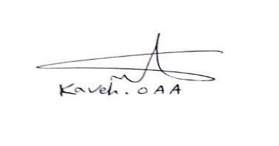
Date:08/17/2017
Place: Iran

