BIOGRAPHY
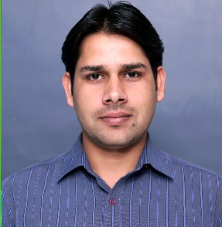

Naveen Kumar, PhD
Dr. Naveen is currently working as full time faculty member in the School of Bioengineering and Food Technology, Shoolini University, Solan (HP), India. He has received his PhD (Dairy Chemistry) from National Dairy Research Institute, Karnal (India) with specialization on nanotechnology and adulteration detection in food products. He did his postgraduate in Food Technology from Guru Jambheshwar University of Science and Technology, Hisar (India). He received many awards and honors. He has published number of articles in journals of national and international repute. His current research interests are in application of nanotechnology in food system, colorimetric methods development for adulteration detection in foods, and technology development for utilization of underutilized wild crops.

