Biography
Dr. Priyanka Debta has completed her M.D.S. in Oral Pathology and Microbiology (2006-2009) from Deemed University S.P.D.C., Sawangi, Maharashtra, INDIA. She has done research in the field of immunological cells infiltration in carcinoma and in odontogenic cysts & in forensic odontology. She has participated in various national and international conferences and presented papers and posters. Presently she is working in I.D.S., SOA UNIVERSITY, BBSR, Odisha, India. Her various studies and reports have been published in the reputed national/international journals. She is a dedicated, resourceful and innovative instructor for her students that helps in intellectual growth by creating an atmosphere of mutual respect and open communication

WMC Dentistry Faculty

Dr. Priyanka Debta
Reader
M.D.S. (Oral Pathology and Microbiology)
E-mail: drpriyanka_1234@rediffmail.com Mobile : +91-9938558663
Marital status – Married, Husband Name – Dr. F. M. Debta.

Current Professional Experience :

Designation: Reader.
Department: Department of Oral & Maxillofacial Pathology and Microbiology.
Teaching Experience:
20th may 2009 to 19th may 2013 – Senior lecturer, [C.D.C.R.I. Sundra, Rajnandgaon (C.G.)]
20th may 2013 to 16th dec 2013 – Reader, [C.D.C.R.I. Sundra, Rajnandgaon (C.G.)]
2nd Jan 2014 to till date, Reader in I.D.S. SOA UNIVERSITY, BBSR.
Academic Credentials :

Master of Dental Surgery (Oral & Maxillofacial Pathology and Microbiology): From Sharad Pawar Dental College and Hospital (Deemed University), Sawangi (M), Wardha, Maharashatra, (May2006-April2009).
Thesis Topic: - Evaluation of prognostic significance of immunological cells (Tissue eosinophils and mast cell) infiltration in oral squamous cell carcinoma.
Bachelor of Dental Surgery: From Sharad Pawar Dental College and Hospital, Sawangi (M), Wardha, Maharashtra, Maharashtra University of Health Sciences Nashik, in July– 2004.

As M.D.S.(Oral Pathology & Microbiology)
- Experience of Frozen Section Reporting & Immunohistochemistry & Special Staining at Dept. of Oral Pathology SPDC, Sawangi (M), Wardha, Maharashtra.

Publications in Indexed Journal
International Peer Reviewed Journal

- 1) Multidisciplinary approach for an initially misdiagnosed case of osteosarcoma in a medically compromised patient. British Journal of Medicine & Medical Research 2(1): 94-104, 2012. SCIENCEDOMAIN international.

- 2) Evaluation of prognostic significance of immunological cells (Tissue eosinophils and mast cell) infiltration in oral squamous cell carcinoma. J Cancer Sci Ther 2011, 3:8.

- 3) Evaluation of infiltration of immunological cells (Tissue eosinophils and mast cells) in odontogenic cysts by using special stains. J of Clinical and Cellular Immunology 2010, 1:103.

- 4) Evaluation of Infiltration of Immunological cells (Tumour Associated Tissue Eosinophils and Mast cells) in Oral Squamous Cell Carcinoma by Using Special Stains. British Journal of Medicine & Medical Research 2(1): 75-85, 2012. SCIENCEDOMAIN international.

- 5) Malignant melanoma of left maxillary alveolus – A rare case report. Applied Science Report 1(3), 126- 130, 2014.

National Peer Reviewed indexed Journal

- 1) Variation in SPC/STC ratio as an indicator of age: A computer-aided forensic odontology. JIAOMR October-December 2010;22(4):S6-8.

- 2) A comparative study between oxcarbazepine and Gabapentin regarding therapeutic efficiency and tolerability in the treatment of trigeminal neuralgia. JIAOMR 2010;22(1):10-17.

- 3) Cervicofacial Necrotizing Fasciitis. JIAOMR 2011;23(4):656-659.

- 4) Photochemotherapy (PUVA): An overview. JIAOMR 2010;22(3):141-143.

- 5) Intraoral Fibrolipoma of lower labial mucosa: A rarevariant of classic lipoma” JODA 2014;3(1):12-15.

- 6) The cancerous bone tumor osteosarcoma: A case report. JRAD 2015,4:3,120-124.

Abstract published :- International conference & Exhibition on Pharmaceutical Biotechnology 2011. "Significance if immunological cell infiltration (TATE) in oral squamous cell carcinoma: A way for discovery of cancer biotherapeutics.

Book
As a co-author: Title: - “Treatment of trigeminal neuralgia” in Nov. 2012 by Lambert Academic Publications Germany.

National Conference:
1) XVII National Conference of Indian Association of Oral & Maxillofacial Pathologists from 27 t0 29 December 2008 at the Oberoi Grand, Kolkata.
2) XVI national conference of Indian association of Oral & Maxillofacial Pathologists from 17th to 19th December 2007 at Khajuraho.

International Conference:
- “International Conference and Exhibition on Pharmaceutical Biotechnology” at Hyderabad International Convention center, Hyderabad, India. On dated 06-08 June 2011. OMICS publishing group.

- International association of Cancer Registries – 8th to 10th oct 2015 – Mumbai.
- International conference on stem cells & cancer (ICSCC-2015): Proliferation, differentiation and apoptosis-2 to 5 ^{th} Oct 2015 – Pune.
- International symposium-Translation from cancer biology to cancer medicine- Manipal-2015.

Convention:
1) VI National PG Convention of IAOMP held on 11th & 12th August 2006 at KLE’s Society’s Institute of Dental Sciences, Belgam Karnataka.
2) VIII National PG Convention of IAOMP held on 20-21st June 2008 at Sharad Pawar Dental College and Hospital, Sawangi (M), Wardha, Maharashatra.

Research work & interests: Her broad area of interest in evaluation of immunological cells infiltration in oral oncology and various odontogenic cyst.

Scientific Paper/Poster Presentations

Sr. No. | Research Particulars | Place and Year
1. | “Significance of immunological cell infiltration (TATE) in carcinoma: A way for discovery of cancer Biotherapeutics” :- Oral Paper Presentation | “International Conference and Exhibition on Pharmaceutical Biotechnology” at Hyderabad International Convention center, Hyderabad, India. On dated 06-08 June 2011. OMICS publishing group.
2. | Evaluation of immunological cells (TATE & mast cells) infiltration in different grades of OSCC- Oral Paper Presentation. | International conference on stem cells & cancer (ICSCC-2015): Proliferation, differentiation and apoptosis- 2-5th oct –Pune.
3. | Prognostic significance of immunological cell infiltration (mast cell) in cancer: Boon or Bane. | International conference on stem cells & cancer (ICSCC-2015): Proliferation, differentiation and apoptosis- 2-5th oct –Pune.
4. | Anti-& Protumourogenic effects of TATE & mast cells on survival of OSCC cases. | International association of Cancer Registries – 8th-10th oct.2015, Mumbai.
5. | Targeted therapies in cancer – A mini review. | International symposium-Manipal2015.  Translation from cancer biology to cancer medicine.
6. | “Evaluation of prognostic significance of tissue eosinophil mast cell infiltration in OSCC” :- Oral Paper Presentation | National Triple “o” symposium 2011: 23rd -24th July, Raipur.
7. | “Evaluation of infiltration of immunological cells (Tissue eosinophils and mast cells) in odontogenic cysts by using special stains” :- Oral Paper Presentation | XVII National Conference of IAOMP from 27 t0 29 December 2008 at the Oberoi Grand,Kolkata.
8. | “Variation in SPC/STC ratio as an indicator of age: A computer-aided forensic odontology” :- Oral Paper Presentation | XVI national conference of Indian association of Oral & Maxillofacial Pathologists from 17th to 19th December 2007 at Khajuraho.
9. | “Aggressive ameoloblastoma- a rare case report” :- Poster Presentation | VIII National PG Convention of IAOMP held on 20-21st June 2008 at Sharad Pawar Dental College and Hospital, Sawangi (M), Wardha, Maharashatra.

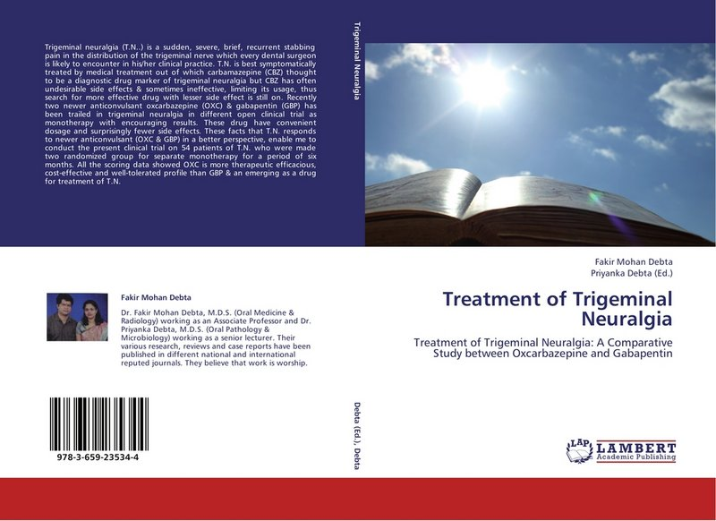

Book published – Treatment of Trigeminal Neuralgia.

Dr. Priyanka Debta

Journal of Clinical & Cellular Immunology
Evaluation of Infiltration of Immunological Cells (Tissue Eosinophil and Mast Cell) in Odontogenic Cysts by Using Special Stains
http://dx.doi.org/10.4172/2155-9899.1000103 2010
156152
154
154

Workshop & symposium:

- National Triple “o” symposium 2011: 23rd -24th July, Raipur. (C.G.).

- “Hands on course on salivary gland immunohistochemistry” held on 22nd July, 2011 at C.D.C.R.I. Rajnandgaon (C.G.).

- Scientific Activity on Saliva: A specimen of choice and psychology in cancer at S.P.D.C., Sawangi, Wardha on 16th Jan 2009.

- Participated in Scientific Activity on Slide Discussion at S.P.D.C., Sawangi, Wardha on 20th Dec. 2008.

- C.D.E. on Chemiluminescence (Vizilite Plus)- Newer Diagnostic modality for Oral Precancer at S.P.D.C., Wardha on 1st Aug 2008.

- C.D.E. program held on 21st Nov.2008 at VSPM’S Dental College and Research Centre,Nagpur.

- Hands on Workshop on PCR at S.P.D.C., DIIMS, Sawangi, Wardha on 17th -18th sep. 2008.

- C.D.E. program held on 8th Aug 2008 at VSPM’S Dental College and Research Centre,Nagpur.

- Participated in the Scientific Activity (Case Discussion) at S.P.D.C., Sawangi, Wardha on 17th march 2008.

- Participated in the Discussions of the Quarterly Slide Seminar at VSPM’S Dental College and Research Centre,Nagpur on 28th Feb 2008.

- CME on Haemato-oncology at J.N.M.C. Sawangi (M), Wardha on the 4th Nov. 2007.

- Participated in the Scientific Activity (Case Discussion) at S.P.D.C., Sawangi, Wardha on 20th Nov. 2007.

- Course on “Clinical Bio-Technology” from 11th-22nd 2007 at Disha institute of

Bio-Technology Pvt.Ltd. Nagpur.

- Post graduate orientation course-2006 on 17th-20th August at S.P.D.C. (DMIMS),Wardha.

- Participated as Delegate in the Guest Lecture by Dr. Borges on Salivary gland Tumours at J.N.M.C., Sawangi (M), Wardha on 26th Feb. 07.

- Symposium on Oral Premalignancy: An Insight at S.P.D.C., DMIMS, Wardha on 17th June 2006.

- “Symposium 2004 Internee” Faculty of Dentistry, organized by Maharashtra University of Health Sciences, Nashik on 22nd Feb 2004.

- Workshop on Fixed Prosthodontics S.P.D.C., Sawangi (Meghe), Wardha on 27th & 28th March 2004.

- 16 hour hands on workshop on Essential Endodontics at S.P.D.C. & Hospital, Wardha, on Feb 9th & 10th 2004.

- Orientation workshop in Oral and maxillofacial Surgery held at S.P.D.C., Sawangi (Meghe), Wardha on 11th & 12th January 2003.

- Indian Dental Association Wardha Branch, 2nd in essay competition held on 7th April 2004.

- CDE programme on medical Emergency in dental practice held on 31st Jan 2014 at I.D.S., BBSR.

- CDE programme on Recent Trends about use of CBCT in dentistry held on 8th March 2014 at I.D.S., BBSR.

- CDE programme on Statistics held on 22nd March 2014 at I.D.S., BBSR.

- CDE programme on Rehabilitation of lost smile” A clinician approach to full mouth Rehabiltation “held on 27th March 2014 at I.D.S., BBSR.

- CDE programme on Forensic odontology – A peek into the future and workshop on Age Estimation, held on 2nd June 2014 at I.D.S., BBSR.

- CDE programme on Bleeding and coagulation: A Dental surgeon’s perspective held on 18th July 2014 at I.D.S., BBSR.

- CDE programme on Emerging trends & future directions held on 8th Nov. 2014 at I.D.S., BBSR.

- KIDS : CDE on oral pathological lesion. 2015,

