Letter of Confirmation to become Editorial Board Member

Name: SANDU Andrei Victor

Designation & Affiliation: Assoc.Prof.PhD.Eng.
Gheorghe Asachi Technical University of Iasi

E-mail: sav@tuiasi.ro

Contact number: +40-745438604

Area of Expertise: material characterisation: microscopy, spectroscopy etc.

Consent Form
I, Assoc.Prof.Dr.Eng. Andrei Victor SANDU am willing to become an Editorial Board member for the “Journal of Powder Metallurgy & Mining” and have understood that I shall fulfil basic requirements for the Journal. I shall satisfy the regular responsibilities bestowed upon me as an Editorial Board Member. I shall be prompt in responding the communications received from the journal office. I assure to follow the standard publication ethics as an Editor. I shall not be biased in taking decision on articles assigned to me and promise to maintain the quality.

Please provide your specific consent as per the requirement:
- I have required academic and professional experience to become Editorial Board Member Yes
- I will stand by the rules and regulations following the guidelines provided by the publisher Yes
- I will render my service to benefit the journal for 2/3/4/5 years Yes
- I will help in soliciting quality manuscript(s) from my colleagues and peers Yes
- I will recommend the Journals to my colleagues and peers Yes

I shall be available to complete timely review for the assigned articles. I shall also support the Journal related promotional activities. As an Editorial board member, I will encourage authors to publish manuscripts in the Journal.

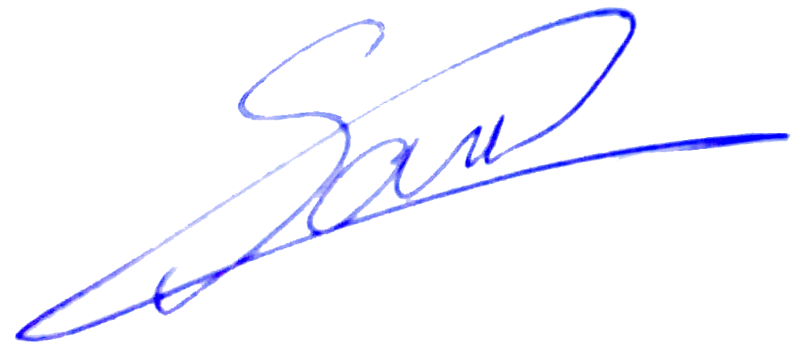
Signature:……………………………………..
Date: 30/08/2017
Place: Iasi, Romania

